**Walkthrough of the User Tracking Application**

**Rahul Raj Sharma**

This document contains a collection of screenshots for the User Activity Tracking Application, which will allow us to better understand the user's various activities and gestures we are tracking using android sensors.

**Step1:** Develop the following application behavior:

1. Your application should start with a greeting to the user with the current date and time. Then immediately recognize the user’s activity (walking, running, in vehicle or still).

**Answer:** Below is the screenshot of welcome screen of the user tracking application

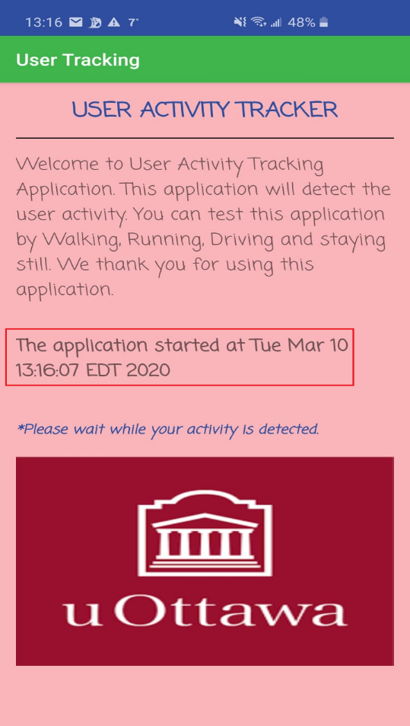

Above screenshot has welcome message for the user along with the application name and uOttawa logo. Highlighted in Red is basically the application start date and time as mentioned in the question.

2. Whenever an activity is recognized, an appropriate picture (your choice) is displayed and text describing the activity is displayed as well.

**Answer:** Below screenshot shows the activities which can application detects and the screens which are displayed.

**Activity 1 – Still**

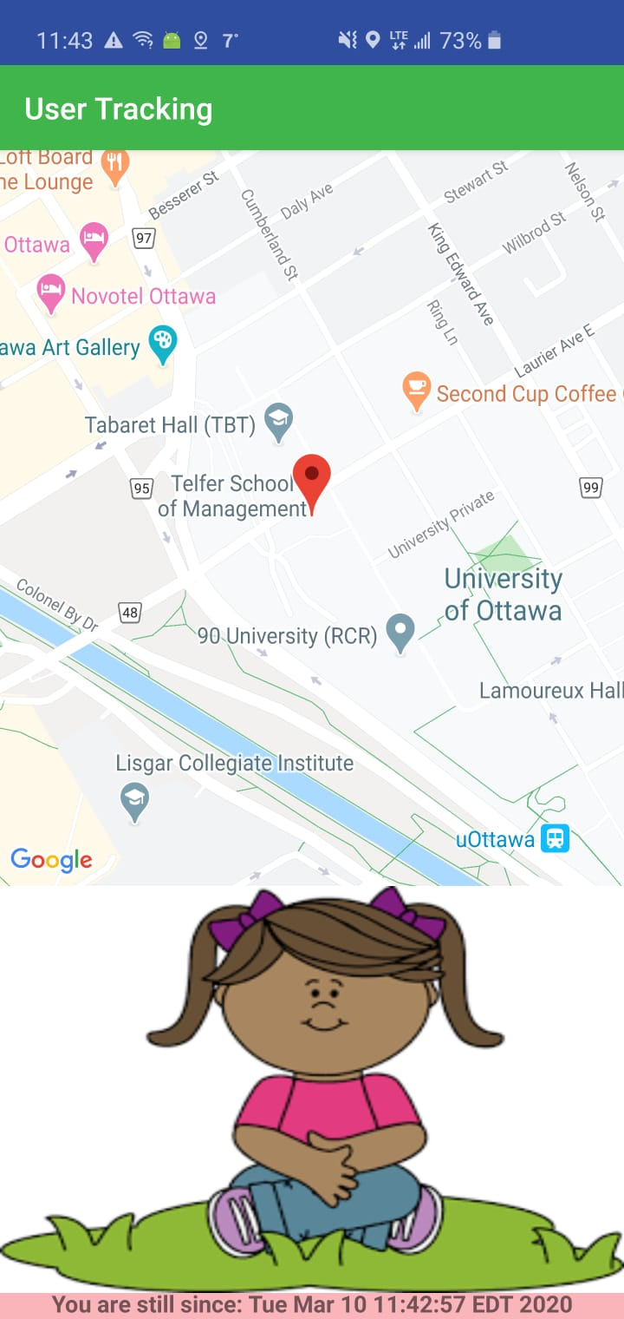

**Activity 2 – Walking**

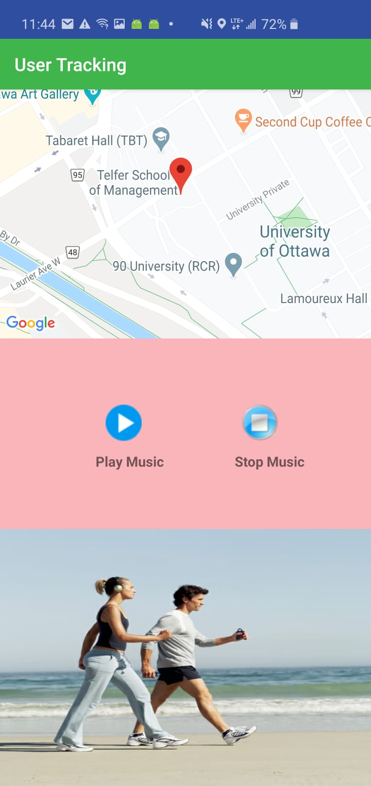

**Activity 3 – Running**

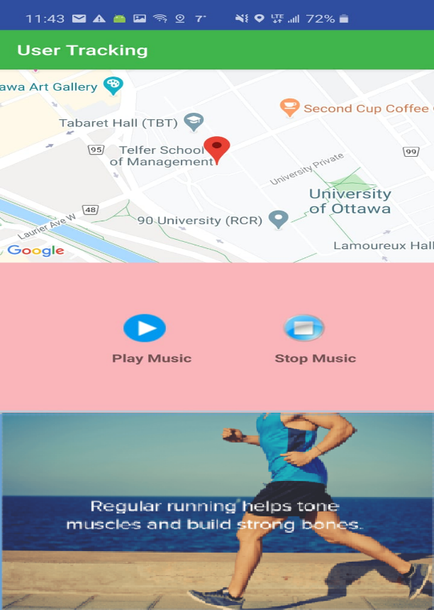

**Activity 4 – Driving**

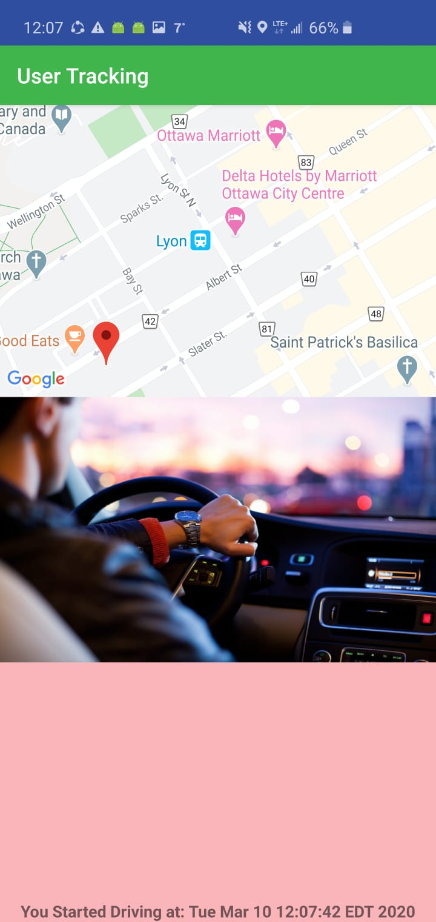

3. Whenever the user is running or walking the app will play music from the device musing list.

**Answer:** Below screenshot shows that the application will start the songs from the list while detects the running or walking activity

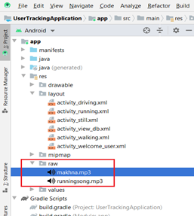

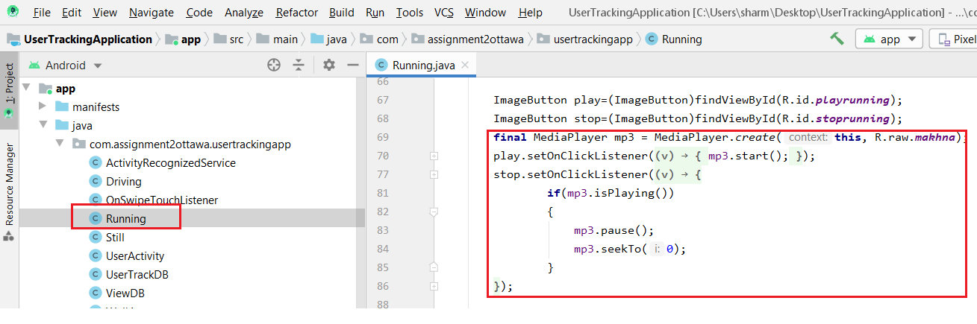

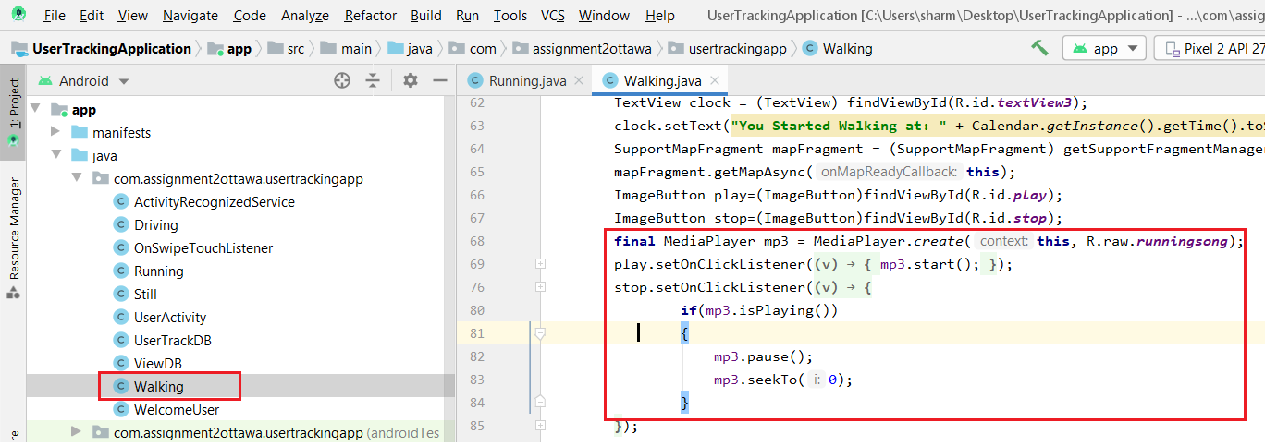

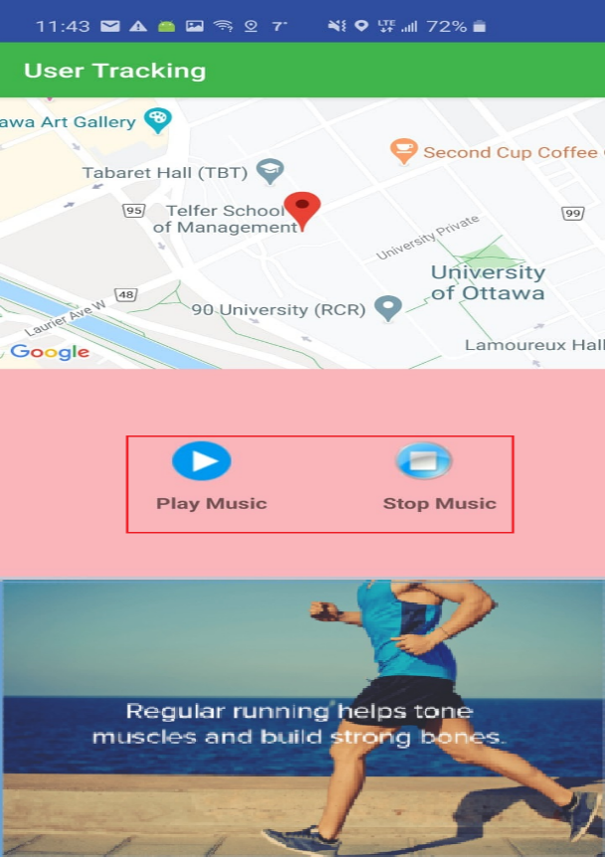 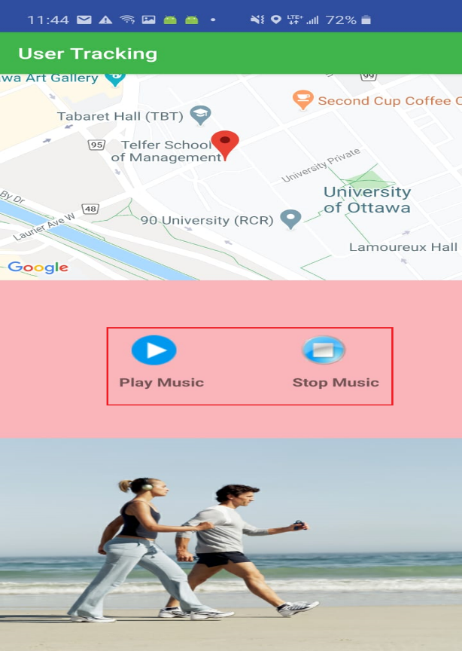

4. When the user is walking, display a map of the current location at the top of the screen.

**Answer:** Below screenshot shows the display of map while user is walking along with the path which followed by the user which is highlighted in Redbox

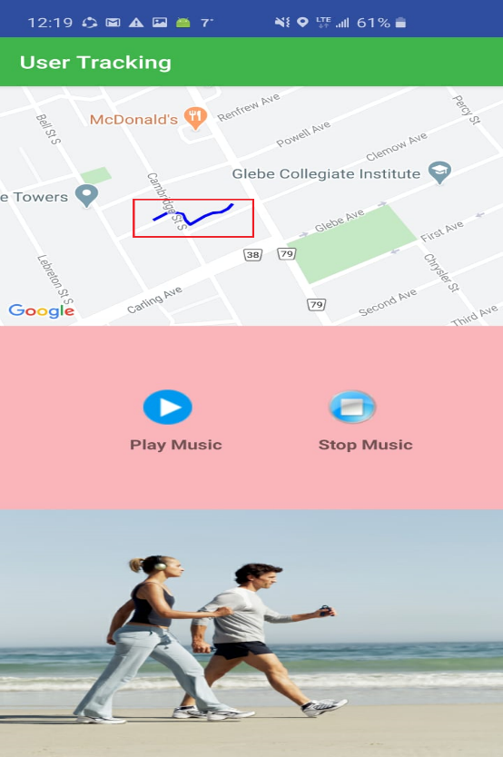

5. Create a local SQLite database to continuously store the start time of each activity along with the activity type. E.g. (12:24, walking).

**Answer:** Below screenshot shows the use of SQLite database and gives the idea how we can see the activities as stored in the database by swiping right in first page

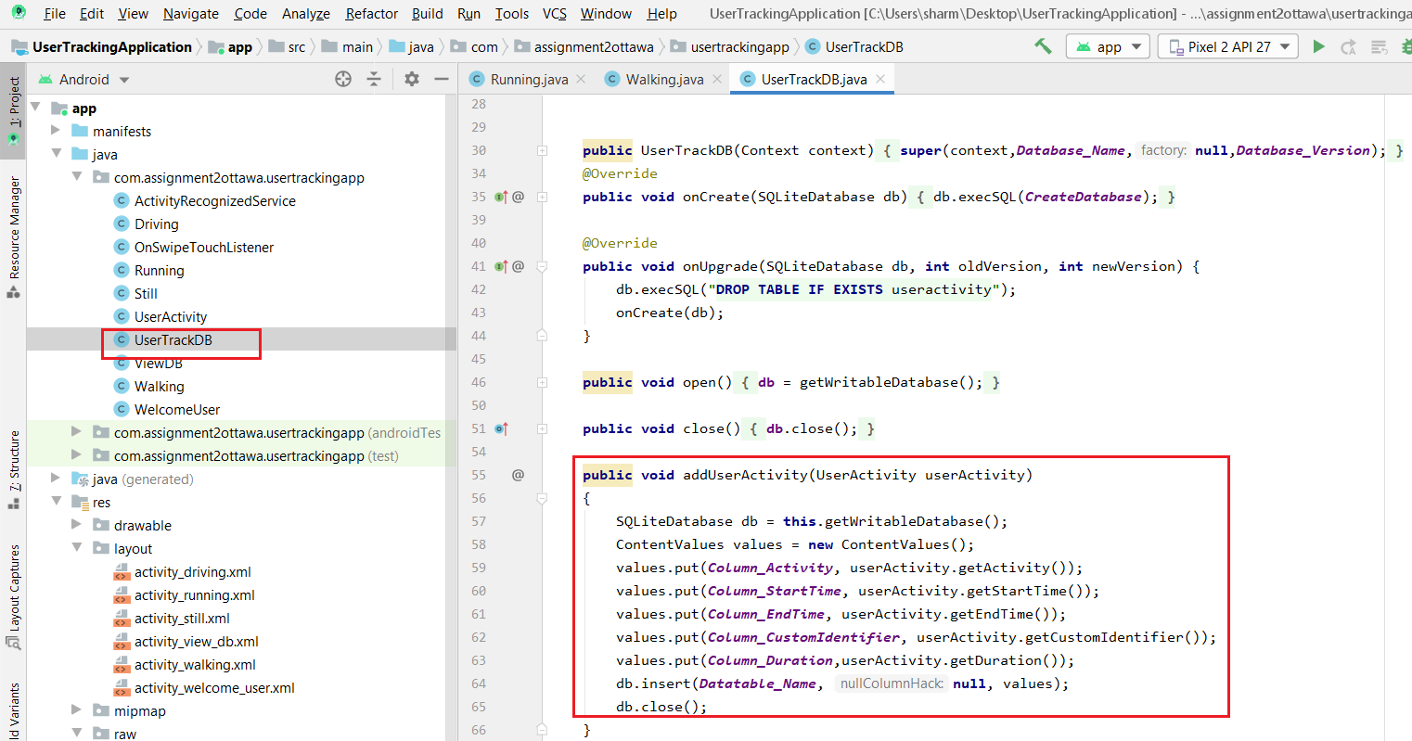

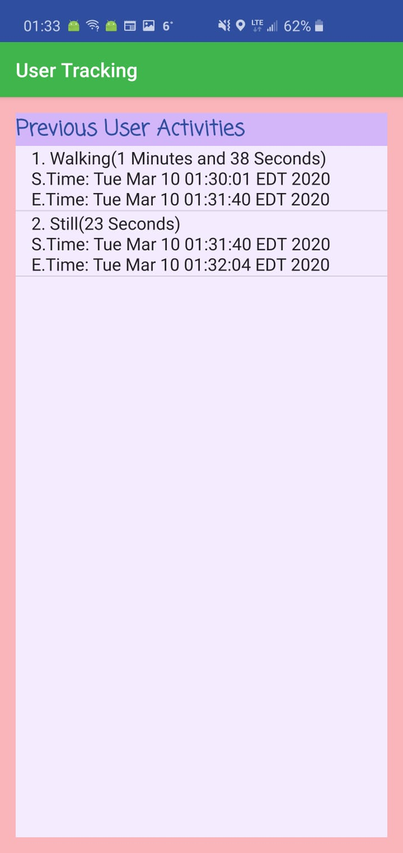

6.Whenever a user switches to a new activity, a message pops up displaying how long the last activity lasted. For instance, if the user was walking and became still, a toast may pop up announcing "You have just walked for 1 min, 36 seconds".

**Answer:** Below screenshot shows the pop-up message when the activity is changed by the user highlighted in red box

**For first activity When activity change**

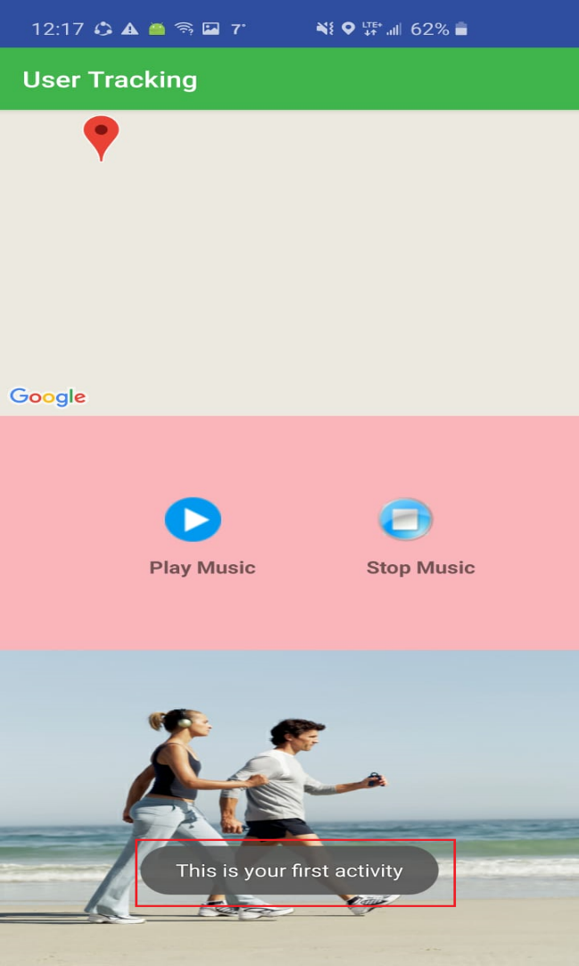 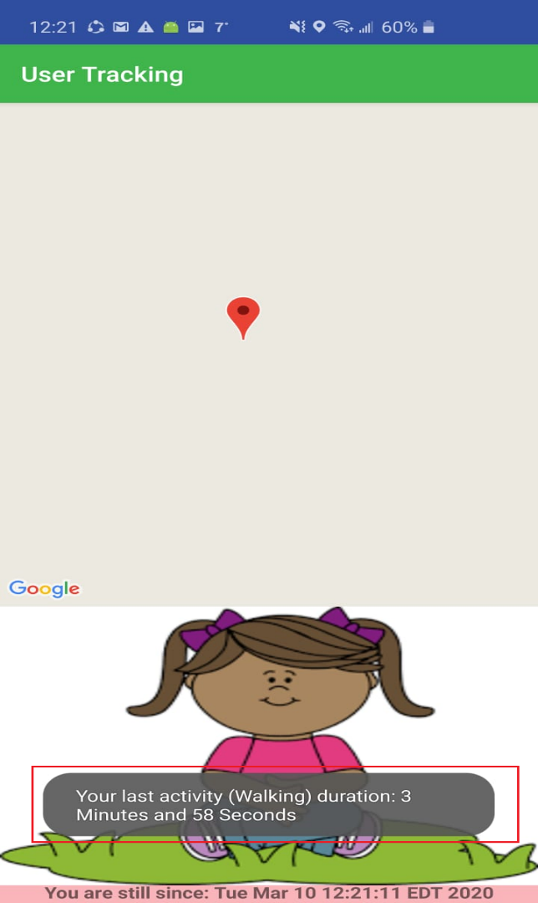

**Step2:** when the user is walking or in vehicle show his/her continuous movement on the map.

**Answer:** Below screenshot shows the continuous moment of the user in map

